AP Biology Name _________________________
Chapter 6 Guided Reading Assignment
10ed

- Explain the difference between magnification and resolving power.

- What is considered a major disadvantage of the electron microscope?
- Study the electron micrographs in your text. Describe the different types of images obtained from:

scanning electron microscopy (SEM)

transmission electron microscopy (TEM)
- In cell fractionation, whole cells are broken up in a blender, and this slurry is centrifuged several times. Each time, smaller and smaller cell parts are isolated. This will isolate different organelles and allow study of their biochemical activities. Which organelles are the smallest ones isolated in this procedure?
- Which two domains consist of prokaryotic cells?

- A major difference between prokaryotic and eukaryotic cells is the location of their DNA. Describe this difference.

- On the figures of a prokaryotic cell, label each of these features and give its function or description.
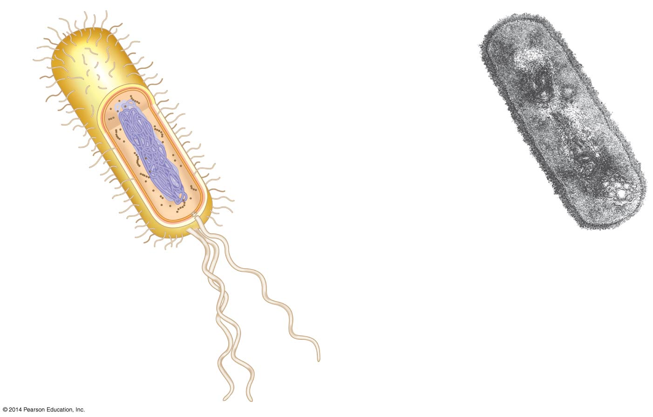
Cell wall

Plasma membrane

Bacterial chromosome

Nucleoid

Ribosomes

Flagella
- Why are cells so small? Explain the relationship of surface are to volume.

- Exchange of materials across the plasma membrane requires a high surface-to-volume ratio. How do the microvilli of intestinal cells facilitate this?

- Image an elongated cell (such as a nerve cell) that measures 125 x 1 x 1 arbitrary units (cell A). Predict how the surface-to-volume ratio would compare with a cell that is 5 x 5 x 5 (cell B) and then calculate the ratio for both cells.

- Describe the nuclear envelope. How many layers does it consist of? What connects the layers? How do molecules such as mRNA pass through the envelope?

- What are the nuclear lamina and nuclear matrix? What function do they perform?

- What are the two components of chromatin? When do the thin chromatin fibers condense to become distinct chromosomes?

- When are the nucleoli visible? What are assembled here?

- What is the function of ribosomes? What are their two components?

- Ribosomes in any type of organisms are all the same, but we distinguish between two types of ribosomes based on where they are found and the destination of the protein product made. Complete this chart based on the differences.
Type of Ribosome | Location | Product
Free ribosomes

Bound ribosomes

- List all of the structures of the endomembrane system.

- The endoplasmic reticulum (ER) makes up more than half the total membrane system in many eukaryotic cells. Use this sketch to explain the lumen, transport vesicles and the difference between smooth and rough ER.
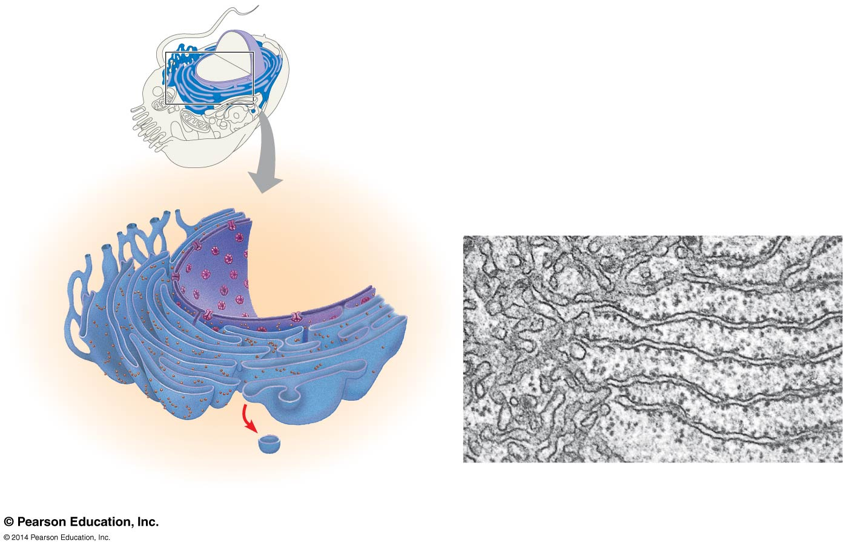
- List and describe the three major functions of the smooth ER.

- Why does alcohol abuse increase tolerance to other drugs such as barbiturates?

- The rough ER is studded with ribosomes. As proteins are synthesized, they are threaded into the lumen of the rough ER. Some of these proteins have carbohydrates attached to them in the ER to form glycoproteins. What does the ER then do with these secretory proteins?

- Besides packaging secretory proteins into transport vesicles, what is another major function of the rough ER?

- The transport vesicles formed from the rough ER fuse with the Golgi apparatus. Use this sketch to label the cisterna of the Golgi apparatus, and its cis and trans faces. Describe what happens to a transport vesicle and its contents when it arrives at the Golgi.
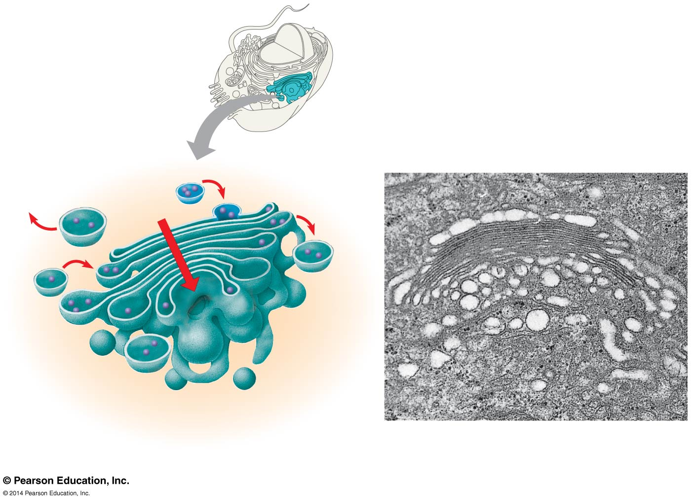
- What is a lysosome? What does it contain? What is the pH range inside a lysosome?

- One function of lysosomes is intracellular digestion of particles engulfed by phagocytosis. Describe this process of digestion. Which human cells carry out phagocytosis?

- A second function of lysosomes is to recycle cellular components in a process called autophagy. Describe this process.

- Explain what occurs in lysosomes to cause Tay-Sachs disease.

- Briefly describe each type of vacuole below.

Food vacuoles

Contractile vacuoles

Central vacuoles in plants

- Label and use this figure to explain how the elements of the endomembrane system function together to secrete a protein and to digest a cellular component.

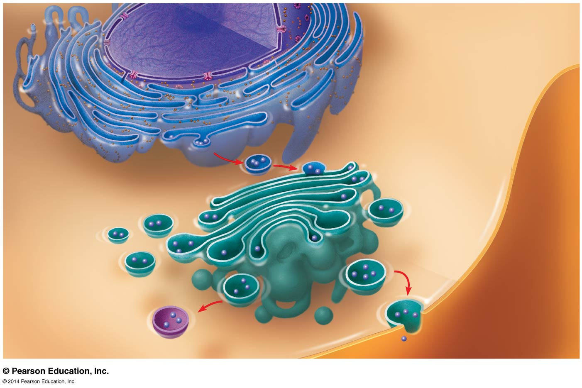

- What is the endosymbiont theory? Summarize three lines of evidence that support the model of endosymbiosis

- Sketch a mitochondrion here and label its outer membrane, inner membrane, inner membrane space, cristae, matrix, and ribosomes.

- Now sketch a chloroplast and label its outer membrane, inner membrane, inner membrane space, thylakoids, granum, and stroma.

- What is the function of the mitochondira?

- What is the function of the chloroplasts?

- Why is the inner membrane of the mitochondria highly folded? What role do all individual thylakoid membranes serve?

- Explain the important role played by peroxisomes?

- What is the cytoskeleton?

- Name the three main types of fibers that make up the cytoskeleton.

- What are three functions of the cytoskeleton?

- Describe several functions of microtubules.

- Animal cells have a centrosome that contains a pair of centrioles. What is believed to be the role of centrioles?

- Compare, and contrast cilia and flagella. For both, select a human cell that has this feature, and describe the role for that cell.

- How do motor proteins called dyneins cause movement of cilia? What is the role of ATP in this movement?

- Study figure 6.26 in your text and explain three examples of movements that involve microfilaments.

- What are the motor proteins that move the microfilaments?

- Give two functions of intermediate filaments.

- What are three functions of the cell wall?

- What is the composition of the cell wall?

- What is the relatively thin and flexible wall secreted first by a plant cell?

- What is the middle lamella? Where is it found? What material is it made of?

- Explain the deposition of a secondary cell wall.

- On the sketch label the primary cell wall, secondary cell wall, middle lamella, cytosol, plasma membrane, central vacuole, and, plasmodesmata.

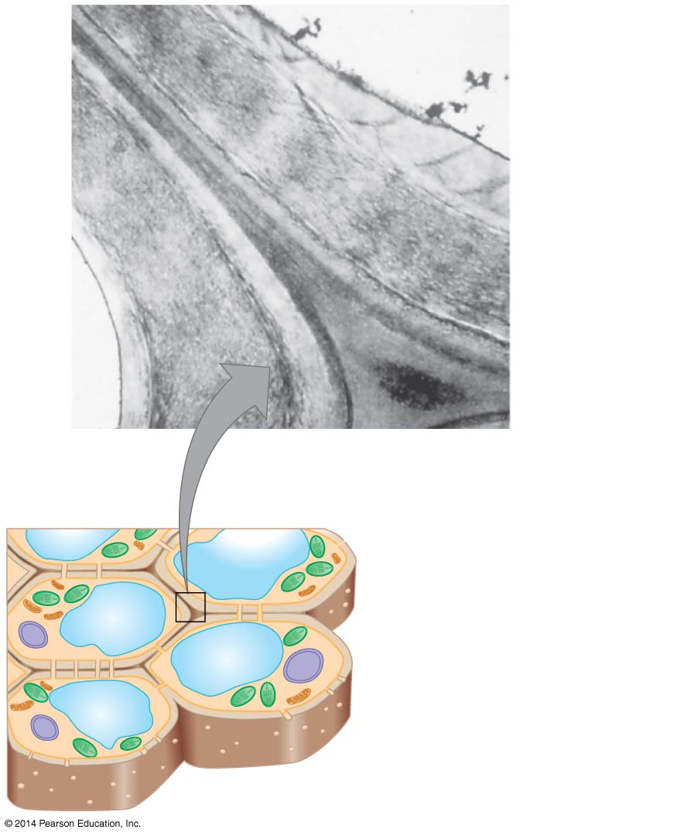

- Animal cells do not have cell walls but they do have an extracellular matrix (ECM). Using Figure 6.28 label the elements in the figure and give the role of each. Also label the extracellular fluid and cytoplasm.

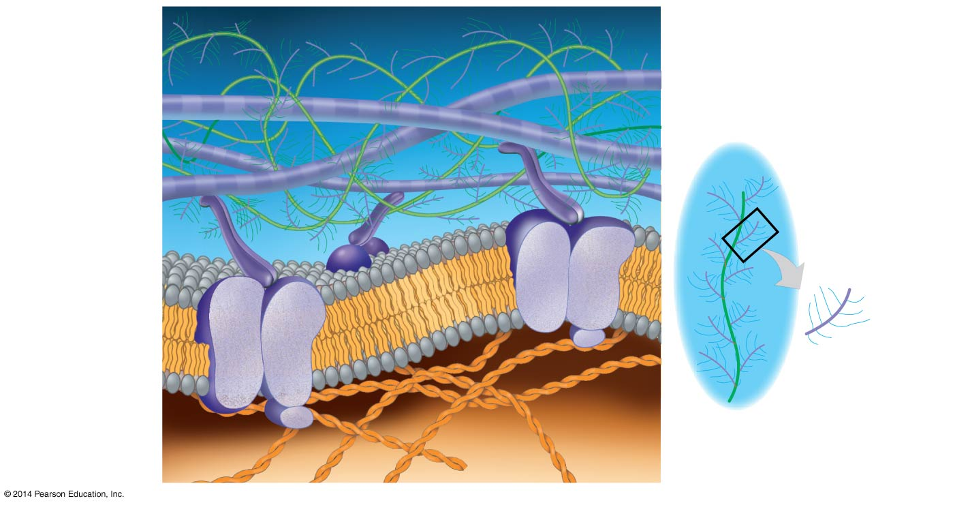

- What are the intercellular junctions between plant cells? What can pass through them?

- Animal cells do not have plasmodesmata. This figure shows the three types of intercellular junction seen in animal cells. Label each type and summarize its role.


